CHECK IN 3
TABLE 1: REGRESSION TABLE FOR SALARY DETERMINANTS.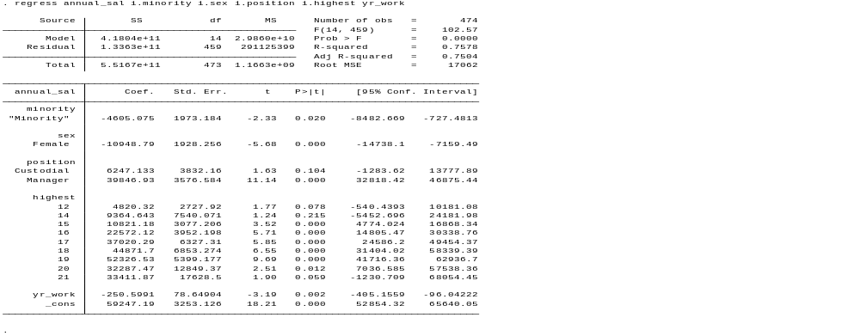
The R-squared value of the model shows that the model explains 75.08% of the variation in the mean annual salary. The variables used make the model statistically significant.
VARIABLE ANALYSIS
Minority-A p-value of 0.233 is greater than 0.05 and making the variable insignificant in the overall model. Other variables explain the initial salary gap of 14,619 dollars. There is not enough evidence for direct salary discrimination based purely on the minority status of employees.
Sex- p-value of 0.00 proves the significance of the variable. A salary of 10949 dollars less is associated with being a female worker in the company. There is enough statistical evidence of salary discrimination based on sex.
Position- p-value of 0.00 is less than 0.05, making the variable highly significant. Being a manager in the company calls for a salary of 39,846 dollars more compared to a clerical worker. We conclude that there is enough statistical evidence of salary discrimination based on the position of a worker in the company.
Years worked- The variable has a coefficient of 0.02, much less than 0.05, and it is therefore significant. However, the small coefficient of -250.59 dollars shows a negative significance, which is not greatly significant compared to other variables.
Highest grade- With a p-value of 0.00, which is much less than 0.05, it is highly significant. After controlling for both sex and position, higher education is associated with a higher salary.
Is there salary discrimination against minorities at Safecorp?
With a p-value of 0.233, which is greater than the significance level of 0.05, minority status is not a significant variable in salary prediction. The initial coefficient of -4,605 dollars has been explained by the other differences in other variables, like education and the position of a worker. We conclude that, based purely on the minority status of a worker, there is no statistical evidence of salary discrimination in the company.
Area of concern and non-concern.
Concern-Safecorp should be concerned about the great salary differences based on gender. A female worker receives 10,949 dollars less compared to a male worker in the company.
Non-Concern-Focusing on position and education, substantial rewards for employees for higher job positions and higher education levels are completely justified and perfectly align with the compensation structure.

